[Title]
  - [Subtitle]
[Kind of Report, targeted Credit Points]
Pechmann, Agnes
[Field of study]
[Matriculation number]
[Semester Year]
[Date]
First Supervisor: | [Name of Professor]
Second Supervisor:

Declaration of authorship
I, [First and Last Name], hereby declare that I have written this [Kind of the report] without any help from others, without the use of documents or aids other than those stated, and that I have cited all used sources correctly according to established academic citation standards. (for Projects)
I hereby declare that I, the undersigned, am the sole author of this document. All sources consulted for this document have been listed; all quotations from and references to these sources have been properly cited and included in chapter notes and in the list of references. No version of this document, either whole or in part, has been used to achieve an academic degree or any other examination.
I understand that any false statements made in this declaration may be punishable by law. (for Thesis)
Place, date |  | Signature  (First and last name)

Confidentiality clause (needs special acceptance of supervisor)
This [Kind of the report] is based on internal and confidential information of the company [name of the company]. Publishing the thesis, part of it and/or making it accessible to other third parties other than necessary within the grading process at the university without the explicit permission of the supervisor and the author is not allowed. After a period of three years, the results can be used anonymous for research and teaching purposes.
Place, date |  | Signature  (First and last name)

Abstract

Table of Contents
List of figures (if applicable) v
List of tables (if applicable) v
List of formulas (if applicable) v
Abbreviations and Symbols v
1 Introduction 5
1.1 Motivation 5
1.2 Objective 5
1.3 Approach to task 5
1.4 Structure of report 5
2 Background / Theoretical part (adapt as necessary) 5
3 Practical part 5
4 Conclusion and Outlook (adapt as necessary) 5
5 References 5
6 Appendix 5

List of figures (if applicable)
Figure 1: Warehouse-Fischertechnik 5
Figure 2: Engraved pen showing project abbreviation and project yearaölskdfjaösldkfjöaslkdfasdfasdf (own source) 5
Add a tabstop before the caption for alignment.

List of tables (if applicable)
Table 1: Table names belong above the table 5

List of formulas (if applicable)

Abbreviations and Symbols

Introduction
Have a look at the PDF Checklist Tips for technical Papers to get hints on how to write a good introduction. The checklist can be found on the lab website.
Splitting this chapter in subchapters with subtitles (see1.1 til 1.4) is not always necessary. Often a clear structure using paragraphs works fine, especially if the subchapters contain only one paragraph or whole introduction is only one page.

Motivation
"Why do want/have to write this report?

Objective

Approach to task

Structure of report

Background / Theoretical part (adapt as necessary)

The clear definition and explanation of basic terms and concepts play a decisive role in an academic paper. This is typically done in the second chapter of the thesis. The purpose of this section is to provide the reader with a solid understanding of the key terms that will be used throughout the thesis. Examples are listed in (Zarte & Pechmann, 2022).
In an academic paper, providing clear definitions and explanations of fundamental terms and concepts is crucial. This typically occurs in the second chapter of the work. The purpose of this section is to give the reader a solid understanding of the key terms that will be used throughout the paper.
Example 3 Performance Indicator: “Throughout this manual, the term perfomance measure refers to an indicator used by managmenet to measur, report, and improve performance. These are classed as either a key result indicator, a performance indicator, or a keay performance indicator.” (Parmenter, 2010, p. 14)
In general, learning factories are “processes that are authentic, include multiple stations, and comprise technical as well as organizational aspects (Abele, Metternich, & Tisch, 2019).” The learning factory users operate in a safe learning environment with specific learning goals and strategies (Abele et al., 2015) . Zarte and Pechmann identify that different learning strategies are applied in various ways using physical learning factories for engineering education in manufacturing.(Zarte & Pechmann, 2020)

Please use the APA citation style in the 6th edition. This style is described for both German and English and is also listed in Citavi.

Practical part
Ölkasdfjö sdfsdf asdfökjöksdf (see Table 1)
Sasdfköasjldkfj
Table 1: Table names belong above the table
Column Header

In Figure 1, the Fischertechnik-warehouse with its white, red and blue products can be seen. The

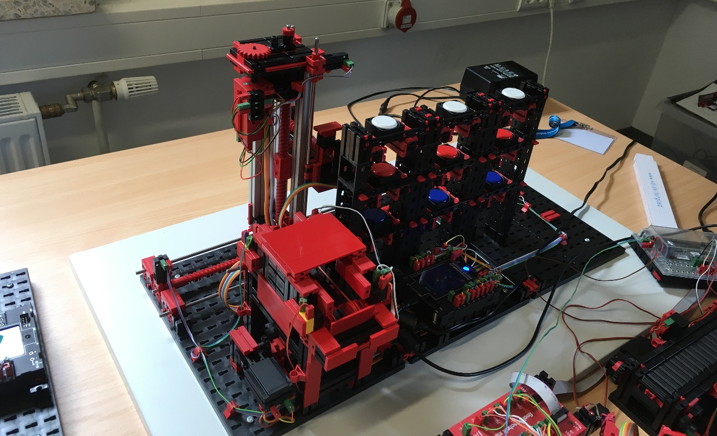
Figure 1: Warehouse-Fischertechnik (own source)
Lorem ipsum dolor sit amet, consectetur adipiscing elit, sed do eiusmod tempor incididunt ut labore et dolore magna aliqua. Magna etiam tempor orci eu lobortis. Rhoncus mattis rhoncus urna neque. Maecenas ultricies mi eget mauris pharetra et ultrices neque ornare. Massa sed elementum tempus egestas sed sed risus. Mauris nunc congue nisi vitae suscipit tellus mauris. Augue lacus viverra vitae congue. Neque viverra justo nec ultrices dui sapien. Adipiscing vitae proin sagittis nisl rhoncus mattis rhoncus. Sodales ut etiam sit amet nisl purus.

Tellus in hac habitasse platea dictumst vestibulum rhoncus est pellentesque. Neque vitae tempus quam pellentesque nec nam aliquam sem. Cras pulvinar mattis nunc sed blandit libero. Blandit cursus risus at ultrices mi tempus imperdiet. Molestie ac feugiat sed lectus vestibulum mattis ullamcorper velit sed. Quis lectus nulla at volutpat diam ut venenatis tellus. Ipsum dolor sit amet consectetur adipiscing. Egestas quis ipsum suspendisse ultrices gravida dictum fusce. Venenatis cras sed felis eget. Lacus vel facilisis volutpat est velit. Non nisi est sit amet facilisis magna etiam tempor orci. Euismod nisi porta lorem mollis aliquam ut porttitor. Urna neque viverra justo nec. Ut sem nulla pharetra diam sit amet nisl suscipit adipiscing. Interdum varius sit amet mattis vulputate enim nulla. Consectetur libero id faucibus nisl tincidunt eget nullam non nisi (see Figure 2).
Faucibus vitae aliquet nec ullamcorper sit. Viverra suspendisse potenti nullam ac tortor vitae. Quis lectus nulla at volutpat diam ut venenatis tellus. At tempor commodo ullamcorper a lacus vestibulum sed arcu. Pretium viverra suspendisse potenti nullam. Ipsum suspendisse ultrices gravida dictum. Mi sit amet mauris commodo quis imperdiet. Nec sagittis aliquam malesuada bibendum arcu vitae elementum curabitur vitae. Adipiscing vitae proin sagittis nisl rhoncus. Neque gravida in fermentum et sollicitudin ac orci phasellus. Adipiscing bibendum est ultricies integer quis auctor elit. Elit sed vulputate mi sit amet mauris comodo quis imperdiet. Ac turpis egestas maecenas pharetra.
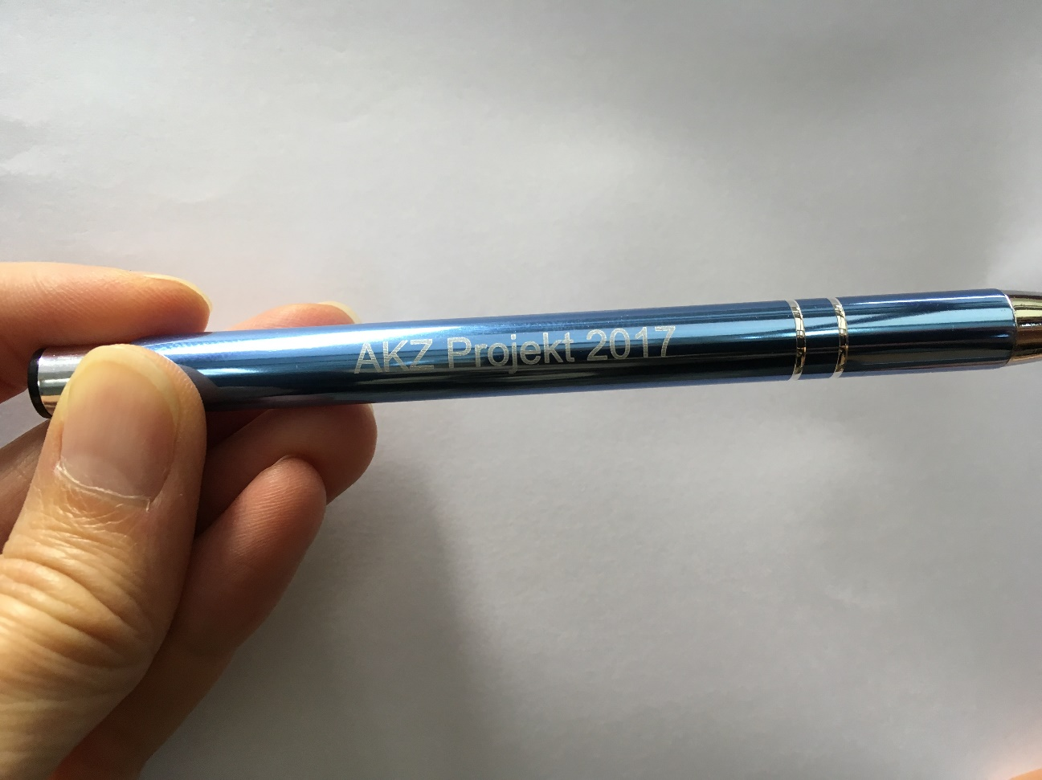
Figure 2: Engraved pen showing project abbreviation and project (own source)
Quis risus sed vulputate odio ut. Cursus mattis molestie a iaculis at erat. Lorem ipsum dolor sit amet consectetur adipiscing elit pellentesque habitant. Donec ac odio tempor orci dapibus ultrices. Tristique senectus et netus et malesuada fames ac turpis egestas. Ac felis donec et odio pellentesque diam volutpat commodo. Et ligula ullamcorper malesuada proin libero nunc. Commodo sed egestas egestas fringilla phasellus faucibus. Facilisis volutpat est velit egestas dui id ornare arcu odio. Risus commodo viverra maecenas accumsan lacus vel facilisis. Vulputate enim nulla aliquet porttitor lacus luctus accumsan tortor posuere. Ut etiam sit amet nisl.

Conclusion and Outlook (adapt as necessary)

References
Abele, E., Metternich, J., & Tisch, M. (2019). Historical Development, Terminology, and Definition of Learning Factories. In Learning Factories (pp. 81–97). Springer, Cham. https://doi.org/10.1007/978-3-319-92261-4_4
Abele, E., Metternich, J., Tisch, M., Chryssolouris, G., Sihn, W., ElMaraghy, H., . . . Ranz, F. (2015). Learning Factories for Research, Education, and Training. Procedia CIRP, 32(1), 1–6. https://doi.org/10.1016/j.procir.2015.02.187
Parmenter, D. (2010). Key performance indicators: Developing, implementing, and using winning KPIs. Chichester: John Wiley & Sons.
Zarte, M., & Pechmann, A. (2020). Implementing an Energy Management System in a Learning Factory – A Project-Based Learning Approach. Procedia Manufacturing, 45, 72–77. https://doi.org/10.1016/j.promfg.2020.04.068
Zarte, M., & Pechmann, A. (2022). Educational Concept and Application of Problem-Based Learning Using a Virtual Learning Factory.

Appendix

